Fly Creeker
NEWSLETTER of the FLY CREEK AREA HISTORICAL SOCIETY (FCAHS)
www:https//flycreekareahistoricalsociety.org
President: Greg Crowell, 607-547-2802; hfcrowell@gmail.com
Editor: Bill Deane, 607-547-4426; billdeane14@gmail.com
VOLUME 38, ISSUE 1 * WINTER, 2026

NEWS BRIEFS

- Do the Dues … Final reminder: 2026 dues are due this month. If your name is not listed on page 5, please use the application on page 6 (photocopies are fine) to renew your membership and keep getting the newsletter (or let us know if we have omitted you in error). Thank you for your continued support of our Society. And welcome to new members, Ancient Wisdom Energy Therapies, Sam Ross, Dr. Richard Sternberg, and Michael & Susan Winnie!

- Save a Tree … We have been distributing the Fly Creeker electronically to many of our members, which saves us paper and postage. If you would like to get future issues that way, please e-mail the editor at billdeane14@gmail.com. Thanks.

- 34 Years a Slave … Congratulations to Pam Deane, who has retired after 34 years as Otsego’s Town Clerk. She more than doubled the old record of 15 years on the job set by George Pomeroy two centuries ago (1825-40). The newly-elected Town Clerk for 2026-29 is Molly Hernandez, and Ted Feury was reelected as Town Supervisor. A complete list of Town Supervisors and Clerks was published in the last Fly Creeker.

- Breakfast of Champions … The October 5 Country Breakfast grossed $1,359 for the Society. We also took in $50 from the raffle, sold a book, and got three new members. Thanks to Tony Kroker and his team of volunteers (including David Zimba and his Boy Scouts) and donors for another successful event. The next one is scheduled for Sunday, May 3 – see you then!

- Building the Fund … Thanks to those who recently contributed to our building repair fund: Carol Hanlon, Denis & Janice Millea, Les & Karen Sittler, and Doris Treadway. This fund is earmarked for ongoing and upcoming repairs needed for our 125-year-old building, including window restoration and roof replacement (we did a temporary repair in 2025 to tide us over). If interested in donating to this fund, please use the line at the end of the application on page 6.

- Position Open … Due to health issues, Deb Mackenzie has resigned as Otsego County Historian. Anyone interested in the position should contact Allan Barnes (barnesal@otsegocountyny.gov) or Steve Wilson (wilsons@otsegocountyny.gov). We wish Deb a speedy recovery.

- Positions Filled … Kevin Brogle has volunteered for, and been appointed as new chairman of, our Archives and Research Committees, responsible for “collecting, cataloging, caring for, arranging, and repairing books, manuscripts, newspapers, artifacts, relics, and other historical material,” and “the coordination and guidance of genealogy and other research.” He has the volunteer assistance of Ruby Pastrana, a first-year student at the Cooperstown Graduate Program. Thanks, Kevin and Ruby!

- You Won’t Be Board … The next quarterly meeting of the FCAHS Board of Trustees is scheduled for Wednesday, April 8 at 3 PM, at the Town building. Members are welcome to attend.

- Ease Our Paint … President Crowell is looking for assistance in scraping and painting the lower portion of our building this spring (no ladders involved!). Please let him know if you can help.

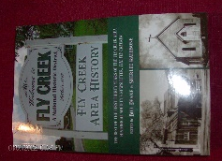
FLY CREEK AREA HISTORY

Each issue, we will include an article from our 2022 book, Fly Creek Area History. The book is still available at the FCAHS/Grange building ($20 for members), and at the Fly Creek General Store and Fly Creek Cider Mill ($25 plus tax for the general public). Copies can also be mailed in the continental U.S. (library rate) for an additional $7 per book.

MAKING CHEESE IN THE TOWN OF OTSEGO
By Peter L. Martin, Spring 2005

The following is condensed from my self-published booklet, “Cheese Factories in Otsego Township,” which doubles as a research compilation and a bedtime story for my great-grandchildren. The booklet contains nearly 20 pages of facts, maps, photos, and sources, plus information about the author. I gave a presentation on this subject at the June 23, 2004 FCAHS meeting.
Cheese-making in the Town of Otsego dates back more than two centuries. According to Old Otsego, a 1953 book by Roy Butterfield, a London publication of 1795 stated that the best cheese in New York was being made on the borders of Oaks Creek. County cheese-makers had an opportunity to show off their wares in 1817 at Otsego’s first New York county fair, where one of the categories was “best twenty pounds of cheese.”
Some early cheese factories produced four cheeses per day, averaging 150 pounds each. The unit size was later reduced to 100 pounds, then to 40- to 60-pound wheels. Each pound of cheese required about ten pounds of milk. A highly seasonal business, cheese was made only from May to November.
By 1840 New York was the nation’s leader in cheese production, accounting for one-third of the total for the United States. The farmland of central New York was the hotbed of the industry, with Rome, N.Y. being called the Cheese Capital of the World. In 1845 the U.S. exported nearly eight million pounds of cheese, mostly to England.
Making cheese at home or on the farm gave way to the rise of cheese factories in the mid- to late-nineteenth century. The farms supplying the milk were invariably within three miles of the factory. Cheese factories in the Town of Otsego included ones located on:
- The northwest corner of Goose Street and Bailey Road, property currently owned by Richard Foutch.
- The east side of County Highway 26 north, opposite Honey Joe Road, currently owned by Fred Knapp.
- Oaksville on the east side of Cat Town Road, currently owned by Judy Thorne.
- The east side of Wiley Town Road, near the corner of Bristol Road, a half-mile east of the Snowden Post Office.
- The south side of State Highway 80, just past the red schoolhouse, currently owned by Richard Schaffer.
- The east side of Huff Road, a half-mile south of Smith Cross Road, currently owned by John Nowlan.
- The south side of Christian Hill Road, opposite Williams Road, currently owned by Joe Ranker [and now by Bill Deane].
Nineteenth-century Otsego factory owners included A. Aufmuth, Babbitt, H. C. Brockway, Menzo Hoke, J. P. Kinney, W. H. Spoonenburgh, the Taylor brothers, Fred L. Young, and L. P. Young.
Developments in refrigeration and transportation reduced the need to manufacture cheese near farmland. In 1892, Otsego County had 80 cheese factories producing 7,094,850 pounds of cheese, but by 1947 that number was down to 796,986 pounds. You could say that cheese-making in the Town of Otsego has gone a-whey.

LETTERS TO THE EDITOR

The Fly Creeker will print letters of general interest about area history, the Society, or the newsletter itself. The Editor reserves the right to edit letters for grammar, space, etc. Address correspondence to Bill Deane, at 408 Christian Hill Road, Cooperstown, NY 13326; or e-mail to billdeane14@gmail.com.

Winter is here! What to do, what to do... Well, while you’re, mostly, inside for the next few months, why not research your family tree?! A great place to start is: familyhistorydaily.com/free-genealogy-sites-and-resources. The site contains a myriad of free articles to help you get started, a comprehensive checklist to help you get organized, and a long list of free sites to help you find information.
So, don’t just sit and lament that you’re stuck inside. Find out if you’re an out-law or an in-law or how many you have. Good hunting!
Layne Weir, Yuma, AZ & Fly Creek

I grew up in New Hartford, N.Y. but now live in St. Louis, Mo. I am researching my family genealogy. Allen Shumway died in Fly Creek on March 9, 1858. His wife was Lydia Keech (Keach). Do you have any information on Lydia? I can trace my line with documents up to this point. Any help with Keech family names would be appreciated. They may have had family or relatives in the area. The Shumway line is well researched, but no one seems to have found Lydia Keech’s family.
Does Fly Creek have information available? Thank you for your time.
Susan Hauf, St. Louis, MO (slhauf@att.net)
MEETINGS & PROGRAMS

The first three FCAHS monthly meetings of 2026 are scheduled for January 28, February 25, and March 25. Meetings start at 6:30 PM in our winter home in the Fellowship Hall (basement) of the Fly Creek United Methodist Church at 852 County Highway 26. In January, Jim Johnson will tell us about the “New York Shakers.” February will feature our annual “Show & Tell” program (preceded by a covered-dish dinner at 5:30); bring along something of historical interest and tell us about it! And in March, Wes Ciampo will give a video-aided presentation about “The Benjamin Family of Fly Creek.”
If you want to update your new calendars, the remaining 2026 meetings are scheduled for April 22, May 27, June 24, July 22, August 26 (Annual Meeting, preceded by covered-dish dinner at 5:30), September 23, October 28, and November 18. All but the November one will be held at the FCAHS/Grange building at 210 Cemetery Road.
The final two meetings of 2025 were held on October 22 and November 19. In October, Oneonta Historian Mark Simonson gave a well-presented and -attended talk on the “Histories of SUNY Oneonta and Hartwick College.” In November, Dr. Chris Kjolhede set out to explain “What Graveyards Can Tell Us about Life & Death,” but it evolved into what they can’t tell us. He gave a lively comparison between the nineteenth century and today in the subjects of health and medicine, life and death.
Following is a list of programs presented at FCAHS meetings in 2025:

Date Speaker/Presenter Topic
1/22/2025 Deb Mackenzie Legends and Leaders of Otsego County
2/26/2025 FCAHS members Show & Tell
3/26/2025 Tom Heitz The Fly in Fly Creek
4/23/2025 Rich Ranieri History of the Civilian Conservation Corps
5.28.2025 Susan Murray-Miller The Cherry Valley Massacre
6/25/2025 Jessie Ravage Mills and Manufactories on Oaks Creek
7/23/2025 Patrick MacGregor Nineteenth-Century Medicine
9/24/2025 Frank Antonucci Fly Creek & 121st Regiment Volunteers of the Civil War
10/22/2025 Mark Simonson Histories of SUNY Oneonta and Hartwick College
11/19/2025 Dr. Chris Kjolhede What Graveyards Can and Can’t Tell Us

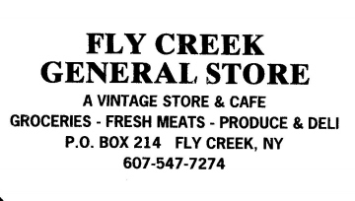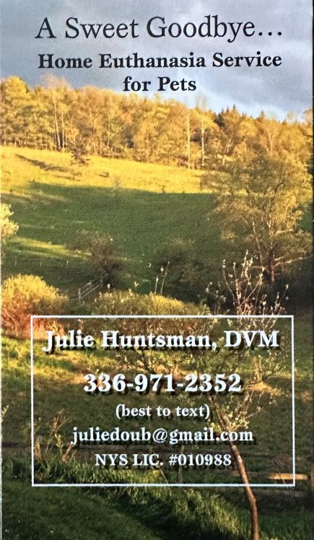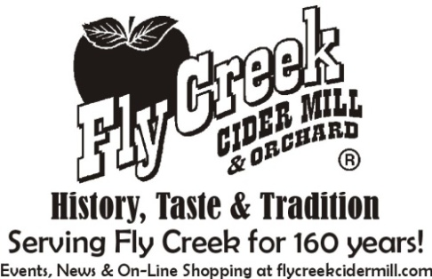

FLY CREEK AREA HISTORICAL SOCIETY: 2026 ROLL OF MEMBERSHIP

AINSLIE, James & Catherine
AINSLIE, Michael
ANCIENT WISDOM ENERGY THERAPIES (B)
ANDREWS, James
BLESSIN, Bev

BOSLEY, Jay & Hudi Podolsky (P)
BOURNE, Floyd & Patrice
BURLEIGH, Doug
CHENEY III, Harold (L)
CLARK, Jane (L)

COCIVI, Jean-Marie
COLLINS, Jr., Perry
COOKE, Dora
CRIPPEN, Katie (L)
CRIPPEN, Tanner (L)

DALTON, Jim & Deb (P)
*DEANE, Bill
DIAL, Beth (P)
DIAL, Jamie (P)
DUSENBERY, Walter & Irene

FLY CREEK CIDER MILL (B)
HANLON, Carol Goddard
HARGROVE, Beverly
HARRINGTON, Angela E.
HARRINGTON, George & Diantha (L)

HARTMANN, Mary Ann
HARVEY, Merritt & *Elaine (C)
HOSKINS, Sam & Peg (P)
JOHNSON, Jim
KEPNER, Claire (L)

KIERNAN, Meg
KROKER, Tony & Sharon (P)
KUCH, Gary & Ellen Tillapaugh
MacLEOD, Mark & Kim
MARBLE, Dale & Jeanne
MARCUS, Brad & Shelley (P)
MARIENFELD, Frederick
McCULLOUGH, John & Susan
MILLEA, Denis & Janice
MOLLACH, Kathryn (P)

MONTESANO, Dominic & Anna
NEFF, Jean (C)
OKERSON, Elizabeth
PHILLIPS, John & Alison
PIERRO, Robert & Kay

POPE, Barbara
PRIOR, Patrick & Anne
ROSS, Sam
SHARPE, Stuart & Bonnie
SITTLER, Les & Karen (C)

SMITH, Mark
SMITH, Mr. & Mrs. Steven (L)
SNYDER, Katherine
STERNBERG, Dr. Richard
SUSMAN, Liz

THORNE, Judy (L)
TOWNSEND, Lyman & Amy
TREADWAY, Doris
WINNE, Robert
WINNIE, Margaret (P)

WINNIE, Michael & Susan (P)
WOLFF, Margaret (L)
ZIMBA, David
------------------------------------------------------

* = Charter Member
(B) = Business/Professional Member
(C) = Contributing/Sustaining Member
(L) = Lifetime Member
(P) = Patron of History

Ancient Wisdom Energy Therapies
Reiki and Shamanic Practices
Suzanne Summers, RN, Reiki Master Teacher
Bonnie Baryk, RN, Reiki Master Teacher
Email - ancientwisdomtherapies@gmail.com
Telephone - (607) 437-4103

2026 MEMBERSHIP APPLICATION
FLY CREEK AREA HISTORICAL SOCIETY
P.O. Box 87, Fly Creek, NY 13337

Name(s): _______________________________________________________________ Renewal ___ New ___

Address: _____________________________________________________________________________________

Telephone: ( ) - e-mail address: ______________________@_____________________

Please register me as a junior member of the FCAHS (age 21 or under). Enclosed is a check for $5.

Please register me as a member of the FCAHS. Enclosed is a check for $15.

Please register us to a family membership (note: this extends to all family members living in one domicile). Enclosed is a check for $25.

Please accept the enclosed tax-deductible donation, in the amount of $_____ (minimum $30 for individuals or $40 for families), and enroll me/us as a contributing/sustaining member(s).

Please register me as a “Patron of History.” Enclosed is a check for $50.

Please register me for a sustaining business/professional membership (includes a business card-sized ad in the Fly Creeker). Enclosed is a check for $90.

Please register me as a Lifetime Member (individuals only). Enclosed is a check for $500 (to be deposited into the Society’s Endowment Fund, or into one of the Society’s general or special funds, at the discretion of the member).
Please accept the enclosed donation, in the amount of $________ toward the building repair fund.
---------------------------------------------------------------------------------------------------------------------

FLY CREEK AREA HISTORICAL SOCIETY
P.O. Box 87
Fly Creek, NY 13337

