Fly Creeker
NEWSLETTER of the FLY CREEK AREA HISTORICAL SOCIETY (FCAHS)
www:https//flycreekareahistoricalsociety.org
President: Greg Crowell, 607-547-2802; hfcrowell@gmail.com
Editor: Bill Deane, 607-547-4426; billdeane14@gmail.com
VOLUME 38, ISSUE 2 * SPRING, 2026

NEWS BRIEFS

- Cleaning Up Our Act … We will hold a clean-up day on Wednesday, April 15 at 10 AM, to get our building ready for the 2026 meeting and event season. Please drop by if you can – many hands make light work!

- Paint by Numbers … President Crowell is looking for assistance in scraping and painting the lower portion of our building this spring (no ladders involved!). Please let him know if you can help.

- A Little Bit Country … Our spring Country Breakfast is scheduled for Sunday, May 3, 8 AM until noon at the FCAHS/Grange building on 208 Cemetery Road, Fly Creek. The all-you-can-eat breakfast includes pancakes, scrambled eggs, sausage, home fries, biscuits & sausage gravy, cider, juice and coffee, all for a historically low price ($12 for members, $14 for non-members, and $5 for kids under 13). Mark your calendars and bring your appetites! Event chairman Tony Kroker is looking for helpers and certain food contributions; please call him (802-345-5757) if you can help. All proceeds benefit the FCAHS in this fund/fun-raiser.

- Moving West … We wish Kathy Snyder hail and farewell as she prepares to move to Liverpool, N.Y. for family reasons. Kathy, daughter of founding members Art & Freida Snyder, has been an invaluable contributor to our local doings in her few years in Fly Creek, leading our Programs Committee, and assisting with our special events and newsletter distribution. Her physical presence will be sorely missed.

- Ethereal … We have been distributing the Fly Creeker electronically to many of our members, which saves us paper and postage. If you would like to get future issues that way, please e-mail the editor at billdeane14@gmail.com. Thanks.

- Meet and Greet … The next quarterly meeting of the FCAHS Board of Trustees is scheduled for Wednesday, July 8 at 3 PM, at the Town building. Members are welcome to attend.

- Many More Members … Thanks mostly to renewals, the following are additions to the roll of membership published in the Winter issue: Kevin Brogle, Bart Brush, Wes & Evette Ciampo (P), Peter & Linda Craig, Greg & Helen Crowell, Pam Deane, Deb Dickinson, Bonnie DuVal, John & Jean Finch*, Jeff & Fiona Fine, Fly Creek General Store (B), Neil & Mary Fogarty, Joseph Hartmann, Martha Helfand, Ed & Connie Hobbie, Tom & Julie Huntsman/A Sweet Goodbye (B), Pat Kennedy (P), Chris Kjolhede & Celeste Johns, David & Janette Lyons, Andrew & Melissa Marietta (C), Susan Miller, Dominic & Anna Montesano, Richard & Diane Richardson, Judy Steiner (C), John & Mary Tedesco, Eleanor Vibbard, Layne Weir & Toni Gray, Mary Winne (C), and Jim Yourno. (B = Business/Professional, C = Contributing/Sustaining, P = Patron of History, * = charter members)

- Building a Fund … Many thanks to the following for their recent donations to our Building Repair Fund: alphabetically, John & Jean Finch, Carol Hanlon, George & Diantha Harrington, Martha Helfand, Pat Kennedy, Tony & Sharon Kroker, David & Janet Lyons, John & Susan McCullough, Denis & Janice Millea, Les & Karen Sittler, John & Mary Tedesco, and Doris Treadway.

(More news briefs on following page)
NEWS BRIEFS, Continued

- Grand Theft Auto … A copy of Fly Creek Area History was in the waiting room of Fly Creek Auto, but it disappeared. We don’t know whether to be angry or flattered!

- Sympathy … To the family and friends of former FCAHS member Judith Jackson, who died recently.

- Coming Attractions … The Activities Committee and Trustees are planning a host of potential events for later this year (in addition to the annual Yard Sale Day and fall Country Breakfast). They include a second attempt at an Antique Appraisal & Museum Day in June; a vintage toy & train display, tentatively scheduled for August 16; and possibly something connected with the America250 movement. Stay tuned for further details!

- Building for Rent … The FCAHS building is available for rent. For full-day use, the rate is $200 for profit-making organizations, $100 for 501 C (3) non-profit organizations, $75 for the general public, and $50 for FCAHS members; the respective rates for half-day use are $100, $50, $37.50, and $25. There is no fee for FCAHS-sponsored events. A security deposit equal to the user fee, and proof of $250,000 liability insurance, are required. There are also fees for a custodian ($15/hour, minimum $60), and for heat, if required ($50). Contact the FCAHS President for further information.

PROPOSED BY-LAWS REVISIONS

The Board of Trustees recommends two revisions to the FCAHS By-Laws, to be voted on at the May 27 monthly meeting.
Our By-Laws Article 1 (1) currently reads, “Any person interested in the history of the Fly Creek area and who applies for membership in an appropriate classification of membership and who tenders the necessary dues shall thereby become a member.”
The Board proposes adding the following sentence: “Voting privileges are extended to a member following 35 consecutive days of membership immediately prior to any election or vote.” The purpose is to discourage people from joining our Society on short notice, solely to disrupt our annual elections, as has happened with other local organizations.
And Article 1 (9) currently reads, “Annual dues shall be payable in advance and no later than January 31 each year.” The Board proposes to change the date back to December 31, as it was until 2024. The reason is that the By-Laws already grant a three-month grace period; extending the deadline to January 31 rewards people who do not renew, and makes the Treasurer’s job harder.
Please be prepared to vote on these at our May 27 meeting. Thank you.

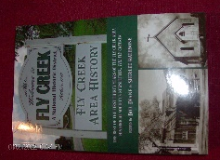
FLY CREEK AREA HISTORY

Each issue, we will include an article from our 2022 book, Fly Creek Area History. The book is still available at the FCAHS/Grange building ($20 for members), and at the Fly Creek General Store and Fly Creek Cider Mill ($25 plus tax for the general public). Copies can also be mailed in the continental U.S. (library rate) for an additional $7 per book.

HISTORY OF THE FLY CREEKER
By Bill Deane, Summer 2007

The following is adapted from the program I gave during the January 24, 2007 FCAHS meeting:
The Winter, 2007 Fly Creeker, which you received in January, was the 71st issue of that newsletter going back to 1989. I have been editor and publisher for each one of those issues – the longest job I have ever held! I figure that qualifies me to give a history of the newsletter, giving us a program that has something to do with Fly Creek and its history.
The Fly Creeker is technically even older than our Society. The Fly Creek Area Historical Society was formally chartered on July 26, 1989, but there were a few organizational meetings before then. I had lived in Fly Creek only two years and hardly knew anyone in the area, but I like history, so I went to the meetings. The first one had 13 people. During one of these meetings, on June 19, 1989, various committees were formed, and one was the Publications Committee. Having had some professional writing experience, I thought that was one I could contribute to, but I didn’t want to be so bold as to volunteer to be chairman. A lady named Musa Gumone was appointed to chair the committee, and I joined it, along with Florence Michaels and Freida Snyder.
The committee arranged to meet at Musa’s house a few days later, and we talked about putting together a newsletter before the Society’s first official meeting. I brought a little article I had written about the Doubleday Baseball, we each contributed some ideas, and we left Musa to bring them all together. So I thought my job was done.
A week or so later, Florence Michaels – who was also acting President of the Society – phoned me. She told me that Musa had suffered a heart attack and was in the hospital. So, Florence wanted me to take over the job of getting out the newsletter. For those of you who didn’t know Florence, she had a way of asking you to do something wherein you understood it was your patriotic duty to do it.
I was able to talk to Musa in the hospital, but she hadn’t really done anything with the newsletter yet. So, it was all up to me, and I had only about a week to get things together. I cut out some pictures, got out my typewriter, and went to work. The result was a two-page effort cleverly entitled, “Newsletter of the Fly Creek Area Historical Society.” As I recall, I ran off a few-hundred copies and we sent them out to just about everyone in Fly Creek.
It’s hard to imagine today, but this little two-page newsletter was a huge hit. By the end of the year, we had gone from that 13-person gathering to a 136-member Society. I was hailed as a savior, and elected the Society’s first Trustee by people who didn’t even know me. When Musa Gumone was back up and around, I tried to give her back her job, but she said I was doing great and could keep it. So, I was officially the editor of the newsletter and, by default, Chairman of the Publications Committee.
At the charter meeting of the Society, we held a contest to name the newsletter. Among the suggestions were Flying through the Past, and the Fly Paper (that was submitted by me, a suggestion of my boss, Tom Heitz). The Fly Creeker, submitted by Rev. Ken Baldwin, was the winning suggestion, earning him a year’s membership to the Society. I, personally, never have been crazy about the name, and would welcome a contest to rename the newsletter!
The plan was to issue the newsletter quarterly, and that’s what I’ve done ever since, publishing in January, April, July, and October each year. I expanded the Fly Creeker to four pages with the second issue, in October, 1989, and it’s been steady at six pages since 1999 – though, if we don’t start getting more material, that may change.
There have been 20 Publications Committee members over the years. Besides the original four, chronologically, they have included Irene Dusenbery, Carol Mezger, Paula Schaeffer, George Badgley, Margaret Eldridge, Marie King, Jim Atwell, Carolyn McLean, Anne Geddes-Atwell, Deborah Dickinson, Robin Moshier, Elaine Harvey, Sherlee Rathbone (who took over as committee chairperson last August), Tom Heitz, Kay Kantorowski, and Gail Rogers. I’d like to give special mention about Carolyn McLean. She joined the committee in 1994, and over the years contributed far more articles than anyone else, with the help of all kinds of historic scrapbooks and diaries she had in her possession. Unfortunately, she has gone through some health problems over the past few years, dropped out of the Society, and is now in an assisted-living residence in Mohawk.
Others who have been helpful to the committee in one way or another over the years include, alphabetically: Art Andrews, Ken Baldwin, Ron Bouton, Marion Brophy, Catherine Christiansen, Wes Ciampo, Irwin Curlis, Pam Deane, Cynthia Ekeland, MerriLynn Fish, Larry Gardner, Katharine Hanor, Merritt Harvey, Margaret Jensen, Claire Kepner, Alice Lavrinos (who used to hand-type all the mailing labels for each issue), Hugh MacDougall, Dorothy Martin, Peter Martin, Barb Michaels, Maxine Potts, Sally Rezen, Zoe Smith, Lois Streett, Jim Wolff, and Margaret Wolff. I hope I haven’t omitted anyone.
The basic procedure of putting together the newsletter includes gathering information on past and future meetings, members, and Society news; writing articles; editing them for grammar and space; laying out and designing the newsletter; copying it; and then folding, sealing, labeling, and stamping the letters for mailing. A few details on these things:
On the layout and design, one thing I wanted was for the columns to line up. In order to do that during my typewriter days, I wrote each article out by hand, hand-copied it onto graph paper, and then knew how many extra spaces to put in each line to make them line up when I typed the final draft. After five years of this, I finally got a word processor in 1994, making my job a lot easier.
On the copying, we’ve been very fortunate. With the permission of Tom Heitz, my boss at the time, I originally used the copy machine at the National Baseball Library. This continued until 1995, by which time neither Tom nor I was working there. Since then, with the permission of the Town of Otsego, we have been using the copier at the Town building; we have only to buy the paper we use.
Another thing I’ve always tried to be conscious of is that the Fly Creeker is a historical record of its own. A hundred or two hundred years from now, I want someone to be able to use the newsletter to find out what was going on in our Society and our community in 1989 or 2007, and have published accordingly. The newsletter is on permanent file at the NYSHA Library, and most of the issues are in our archives as well.
Years ago, I put together an index to the Fly Creeker, but there wasn’t much interest in it, and it got to be too unwieldy, so I gave up on it in 1997. Sherlee Rathbone expressed interest in resurrecting and updating this project, so I gave her a set of newsletters and my previous work in 2004. She is presumably still working on this, along with all of her other jobs within the Society.
So, that’s the story of the Fly Creeker, now consisting of 73 issues totaling 374 pages.

(Editor’s note: Another 19 years have passed since this article was written, so it now represents less than half of the Fly Creeker’s history. We’re now up to 149 issues and 935 pages, and most of the people mentioned are long gone. The rest of the story will have to wait for a later date.)

A BRIEF HISTORY OF BROOKWOOD POINT
By Edward Rowley

(Editor’s note: this article was originally published in the 2021 Brookwood Point calendar, and is reprinted with the permission of the author and Otsego Land Trust, Inc.)

Otsego Lake has been visited by humans for thousands of years. Brookwood Point, with its gently sloping land, its lovely brook, wetlands, quarter mile of shoreline, and deep water just offshore, would have been a logical place for those early visitors to stop – a good place to find food. As an 1851 real estate advertisement noted, 200 pounds of fish had been speared from Brookwood Point in a single night.
One of the first entries in Brookwood’s abstract of title describes Col. George Croghan’s 1768 acquisition of 245,000 acres of land from the Iroquois Indians, including Brookwood Point. Croghan established a small settlement at the foot of the lake, but deeply in debt, he left in 1770, never to return.
The Revolutionary War suspended further settlement of this area until the war’s end. In 1785, William Cooper, a merchant from Burlington, N.J., acquired 20,350 acres of Croghan’s land in a foreclosure auction. In related litigation, Cooper was represented by Alexander Hamilton and an opposing party, Benjamin Franklin’s son William, was represented by Aaron Burr.
In 1794, William Cooper sold 155 acres to Zebulon Metcalf from Lebanon, Conn., including the 22 acres of today’s Brookwood Point. The price was 108 pounds, 14 shillings. In 1832, Zebulon’s son Charles Metcalf sold Brookwood to his stepbrother, Cyrenus Clark, a master carpenter and joiner. He built a Greek Revival farmhouse on the north side of Brookwood Creek. Beginning in 1817, he was the carpenter at Hyde Hall, and in 1825 built the covered bridge there, the oldest still standing in the United States. (Its bicentennial was celebrated on October 11, 2025.)
Cyrenus Clark and his wife Mary lived at Brookwood until 1849, when they sold it to Edward Daniels. In 1852, the Danielses sold it to James Clonney, a foremost American genre painter. His painting Politicians in a Country Bar hangs in the Fenimore Art Museum, the gift of Stephen Clark, Sr.
In 1855, Clonney and his wife Margaret sold Brookwood to Edward Maynard, a world traveler, prominent dentist, and firearms inventor from Washington, D.C. His Maynard carbine was used by both the North and the South during the Civil War.
In 1863, Brookwood was bought by Henry Winn, a Major in the Civil War, lock manufacturer, author, and politician. His wife Madelíne, of the Yale Lock family, was an artist and prominent member of the Arts and Crafts movement of Chicago and Deerfield.
In 1869, the Winns sold the property to Elihu Phinney III, from the publishing family of Cooperstown and Buffalo.
In 1879, Brookwood was acquired by James Barclay Jermain as a summer home. Jermain was a wealthy businessman from Watervliet, N.Y., on the Hudson River. His granddaughter, Katharine Jermain Townsend, inherited the property in 1897. She and her husband Frederick De Peyster Townsend of Buffalo had a profound impact on Brookwood Point as we see it today. Frederick, a Harvard-educated landscape architect and WWI veteran, designed the Brookwood Gardens and the Garden House. They and their seven children made Brookwood a social center, putting on plays and hosting authors, artists, and frequent charity fundraisers.
In 1944, Katharine sold Brookwood to J. Harry Cook, a Cooperstown businessman. The
Cooks’ son Bob took over Brookwood in the mid-1960s. Bob was a WWII veteran, a survivor of Pearl Harbor, and the last private owner of Brookwood Point. In 1985, he created a foundation and deeded the property to it. His feelings about Brookwood Point and the surrounding area are clear from his foundation’s name: The Cook Foundation for the Preservation and Beautification of Cooperstown and Otsego Lake.
In 2011, the Cook Foundation merged with the Otsego Land Trust. Its mission statement: The mission of Otsego Land Trust is to improve the quality of life throughout the Upper Susquehanna region by enhancing climate resilience, promoting public access to nature, and working with landowners and partners to protect and conserve local farmland, forests, and waters in perpetuity.
Please help us keep Brookwood’s quiet beauty safe, open to the public, and free of charge. Donate today at otsegolandtrust.org, or by mail to P.O. Box 173, Cooperstown, NY 13326. Thank you!
Author’s note: In 1985, I learned that Brookwood Point was being opened to the public by the Cook Foundation. Since then, I have been a frequent visitor. In 2011, I began attending meetings at the Otsego Land Trust to explore Brookwood’s future. I started researching the history of Brookwood, as well as volunteering for the spring and fall cleanups, giving history tours at Brookwood and supporting the Land Trust to help ensure that Brookwood will be preserved for the public to enjoy.

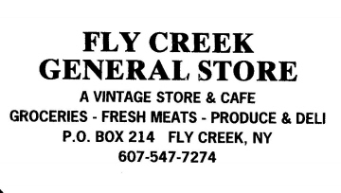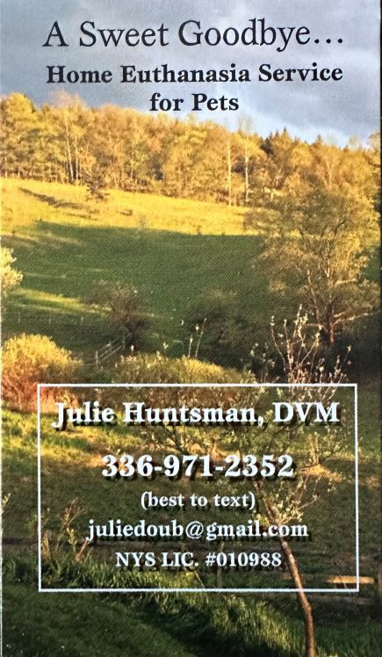

Ancient Wisdom Energy Therapies
Reiki and Shamanic Practices
Suzanne Summers, RN, Reiki Master Teacher
Bonnie Baryk, RN, Reiki Master Teacher
Email - ancientwisdomtherapies@gmail.com
Telephone - (607) 437-4103

BREAKING NEWS!
By Kevin Brogle

For a small hamlet, Fly Creek has had its share of newspapers in its history.
Newspaper publication in Fly Creek was thought to have begun with the Fly Creek Pastoral Visitor, which published monthly over a two-year span from April 1882 to April 1884. It was created by Rev. Benjamin P. Ripley, pastor of the Fly Creek Methodist Episcopal Church.
Fly Creek’s next newspaper was the Fly Creek Gazette, published “semi-occasionally” by the 16-year-old John B. Hooker, Jr., in 1885. The Gazette, unfortunately, lasted only two issues.
The Fly Creek Hustler followed in about 1893, published for S. Wilson Cheney, proprietor of Cheney & Co., a store located next-door to where the Fly Creek General Store currently sits.
This history has been well-established by Bill Deane and Carolyn McLean, who published it in the Fly Creeker (Fly Creek’s only current newspaper) in 1997, and reprinted it in Fly Creek Area History.
Now comes news of two newly-discovered local newspapers, The Amateur Press and The Recorder. These were discovered by the author in a box of family papers. The Amateur Press was first published in January 1873 by then 15-year-old Will E. Leaning, great-great-uncle of the author. This not only makes The Amateur Press the oldest-known newspaper in Fly Creek, but also makes Leaning the youngest publisher. Will seemed destined to be a printer/publisher. At age 14, in July 1871, he began advertising himself as an “Amateur Job Printer,” based in Fly Creek. But he was not the first printer in the family. His uncle, William Leaning, was a printer and typesetter for the New York Herald and, later, the New York Times.
The Amateur Press itself was published monthly from January 1873 to August 1874; three volumes of six issues and one issue of the fourth, and likely final, volume for a total of 19 issues. It was published in a 6x7½” format (enlarging to 6x9½” with Volume 3). It had the motto “Juniores ad Labores”: Young Men for Labors.
The Amateur Press contained an assortment of poetry and prose, some of both written expressly for the paper. Also included were humor, puzzles, advertisements, and notices. Little to no actual news stories were published in the paper. One death notice appears in Vol. 3, No. 5 for Allie Murdock, who died at the age of eight in Phoenix Mills.
Amateur publishing was growing at this time. In 1873, at Syracuse, the Empire State Amateur Press Association (ESAPA) was established. In July 1874, Will Leaning, age 17, was elected secretary of the ESAPA and in July 1875, at the annual convention, held in Cooperstown, he became the association’s President at age 18. His second newspaper, The Recorder, was published as a souvenir of that meeting, existing for only one issue.
Leaning’s destiny came to fruition at the age of 24, when he purchased a half-interest in the Gloversville Intelligencer and Johnstown Republican. His partner in this business was A. E. Blunck. Eventually, Blunck and Leaning went their separate ways with Blunck taking control of the Johnstown Republican and Leaning, the Gloversville Intelligencer.
Sadly, Will Leaning passed away in 1890, at the young age of 33, from consumption. He left a widow, the former Florence Hooker (first cousin of the Gazette publisher), and a seven-year-old son, Eugene.

(Editor’s note: Kevin Brogle will plan a program on Will Leaning and his newspapers for a future FCAHS meeting.)

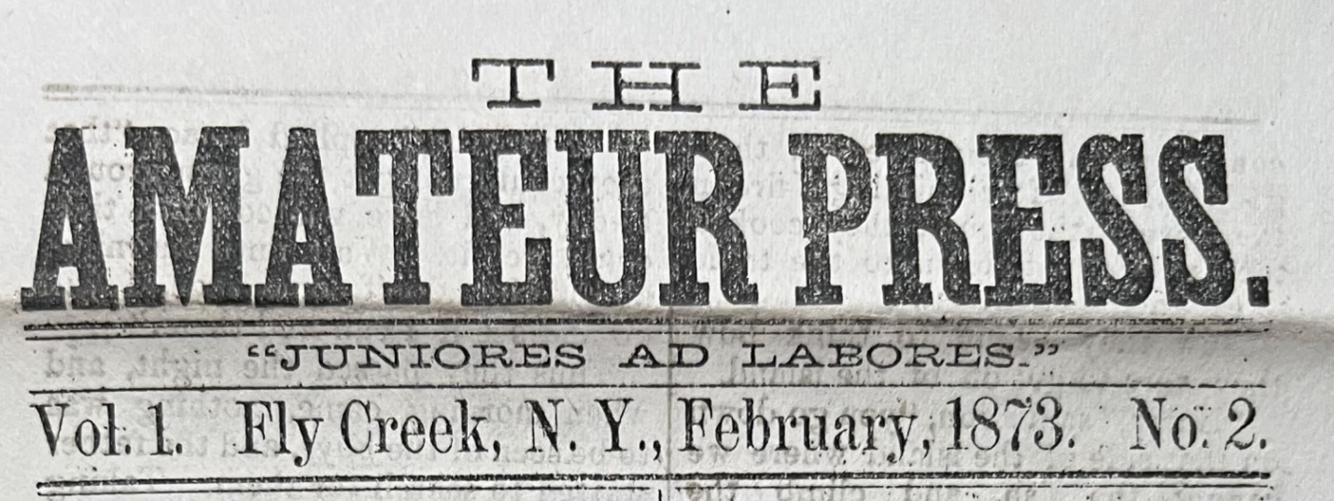
MEETINGS & PROGRAMS

The next three FCAHS monthly meetings are scheduled for April 22, May 27, and June 24, 2026. Meetings start at 6:30 PM at the FCAHS/Grange building at 208 Cemetery Road. More details will follow in local newspapers, posters, and our web-site.
In April, Dr. Cindy Falk will present “The Changing Rural Landscape.” Cindy is Associate Dean of Graduate Studies at SUNY Oneonta and Professor of Material Culture at the University’s Cooperstown Graduate Program, and led the Fly Creek walking tours the past two summers.
In May (rescheduled from last year), we will meet at the former Fly Creek Trolley Station at 187 Cemetery Road, where Les Sittler will give a history and tour of that building, before we proceed to our own home for the regular meeting.
And in June, Abigail Mosenthin, DrPH, MPH, CIC and Alex Scorzafava from the Otsego County Department of Health will present “Tick-Borne Diseases in Otsego County: Awareness, Prevention, and Protection.”
Our three most recent meetings were held on January 28, February 25, and March 25. In January, Jim Johnson told us about the “The Marketing of New York Shaker Craftsmanship and Design,” and about the Shakers themselves. The European Shaker movement entered the United States at what is now Watervliet, N.Y. in 1784, and by the mid-19th century its community in New Lebanon was producing the high-quality furniture which is still prized by collectors.
February featured our annual “Show & Tell” program. Among the items shown and told about were Civil War documents, hand-made musical recorders, the clock from a 1927 electric stove, part of a pitchfork made in Fly Creek, a South American art relic, a British police whistle, a 1700s bed-warmer, a 1985 Fly Creek cookbook, and the jawbones of a shark.
And in a sparsely-attended March meeting, Wes Ciampo gave a video-aided presentation about “The Benjamin Family of Fly Creek.” The Benjamins had a large presence in the area in the nineteenth and twentieth centuries, including a farm near Wes’s home on Keating Road. He shared genealogical research from Benjamin descendant Bonnie Lee DuVal, and relevant photos, documents, and artifacts.

---------------------------------------------------------------------------------------------------------------------

FLY CREEK AREA HISTORICAL SOCIETY
P.O. Box 87
Fly Creek, NY 13337

